File permissions in Linux

Project description
In this project, I audited and managed file and directory permissions in a Linux environment for a research team. By utilizing bash commands to uncover hidden files and modify existing permissions, I removed unauthorized access and aligned the system with the organization's security policies. Ultimately, this ensured the system adhered to the principle of least privilege to protect sensitive research drafts.

Check file and directory details
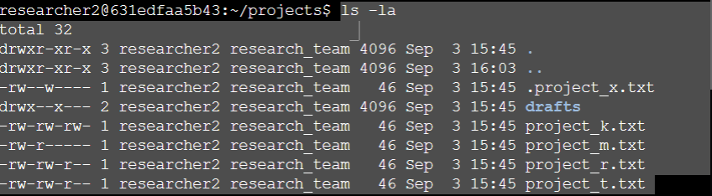

•Command: ls -la

•Explanation for the document: The ls command lists the contents of the directory. Flag -l formats the output in a detailed list that displays the 10-character permission string, the owner, and the group. Flag -a ensures that hidden files (those that start with a dot, such as .project_x.txt) are also displayed.

Describe the permissions string
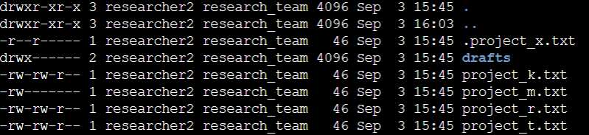
The 10-character permissions strings define the file type and the access levels for the owner, group, and other users on the system. Using the entry -rw-rw-r-- for project_k.txt as an example, the string is structured as follows:
- First character (File Type): Indicates the nature of the item. A dash (-) denotes a regular file (like project_k.txt), while a d denotes a directory (like drafts).
- Characters 2-4 (Owner): Dictate the permissions for the file owner (researcher2). In this example, rw- means the owner has read (r) and write (w) access, but no execute (-) permission.
- Characters 5-7 (Group): Dictate the permissions for users in the assigned group (research_team). Here, rw- grants the group read and write access.
- Characters 8-10 (Others): Dictate the permissions for any user not owning the file or in the group. The r-- indicates that others only have permission to read the file.

Change file permissions
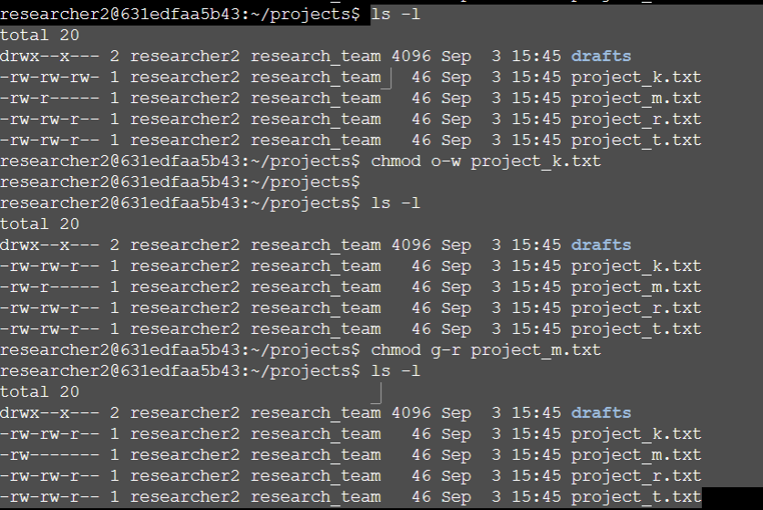
Command used: chmod o-w project_k.txt

Explanation: the project_k.txt file initially had the permissions -rw-rw-rw-, indicating that the "others" category had writing permission. The chmod command was used to modify these permissions. The o-w syntax instructs the system to remove (-) the writing permission (w) for the other users (o). The output of the subsequent ls -l command confirms that the permissions have been successfully updated to -rw-rw-r--, removing unauthorized access.

Change file permissions on a hidden file
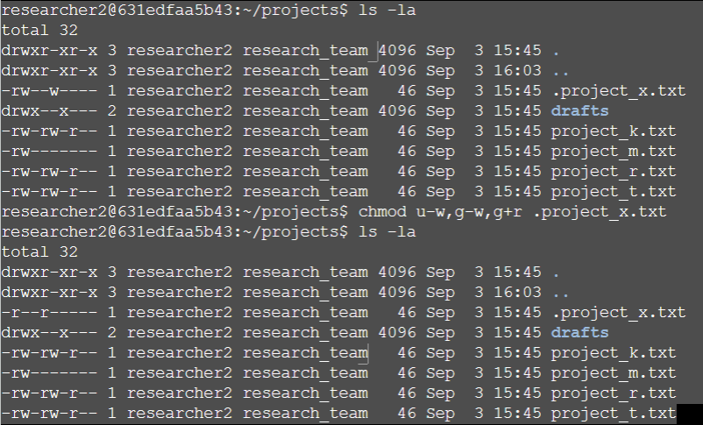Command used: chmod u-w,g-w,g+r .project_x.txt

Explanation: the hidden file .project_x.txt initially had the permissions -rw--w----. The command executed on the terminal uses specific symbolic modifiers to adjust the accesses instead of absolutely resetting them:

u-w: Removes user's writing permission (owner).

g-w: Removes the group's writing permission.

g+r: Adds the read permission to the group.

The subsequent output of the ls -la command confirms that the permissions have been updated to -r--r----, successfully ensuring that the write permission has been removed for everyone and that only the user and group have read access.

Change directory permissions
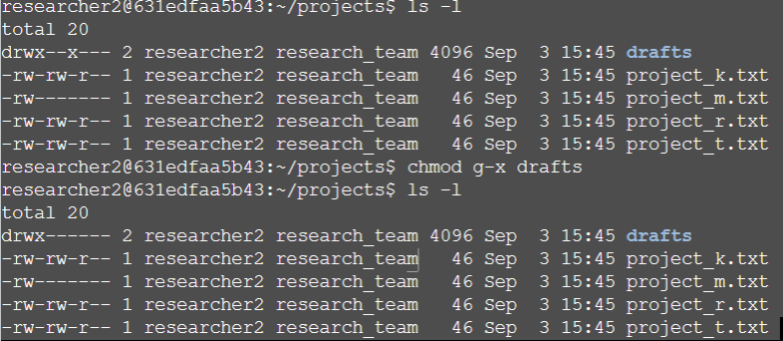

Command used: chmod g-x drafts

Explanation: the drafts directory initially had the drwx--x--- permissions, which granted the execution permission (access to the directory content) for the group. The chmod command was executed using the g-x syntax, which instructs the system to remove (-) the execution permission (x) for the group category (g). The output of the subsequent ls -l command confirms that the permissions have been updated to drwx------, blocking the group access and ensuring that only the owner (researcher2) can access the directory.

Summary
In this scenario, I successfully audited and managed file permissions within a Linux research directory to strengthen system security. Utilizing commands like ls -la and chmod, I identified unauthorized access levels and modified them to align with organizational policies. By removing excess write permissions, securing hidden files, and restricting directory access exclusively to the owner, I ensured that the principle of least privilege was strictly enforced.

